Selenium Assignment 01 - WebDriver Fundamentals
This chapter presents the elementary aspects of the Selenium WebDriver API. To that aim, we review first the different ways to create instances of the WebDriver hierarchy (e.g., ChromeDriver, EdgeDriver, FirefoxDriver, etc.). Also, we explore the main methods available in these objects. Among them, locating the different elements in a web page is essential. Thus, you will discover the possible locators, i.e., strategies to find the elements within a web page (called WebElement in the Selenium WebDriver API), such as by tag name, link text, HTML attribute (identifier, name, or class), CSS selector, or XPath. Another critical aspect of the Selenium WebDriver API covered in this chapter is the impersonation of user actions (i.e., automated interactions with web pages using the keyboard and mouse). The last part of this chapter presents the ability to wait for web elements. This feature is critical due to the dynamic and asynchronous nature of web applications.

Basic WebDriver Usage
This section covers three fundamental aspects related to WebDriver objects:
- First, we review the different ways to create them.
- Second, we study their basic operations.
- Finally, we analyze the different ways to dispose of them (at the end of tests, for closing the browser).

WebDriver Creation
As introduced, to control browsers with Selenium WebDriver in Java, the first step is to create WebDriver instances. Thus, we need to create a ChromeDriver object when using Chrome, EdgeDriver for Edge, FirefoxDriver for Firefox, and so on. The basic way to create instances of these types is to use the new operator in Java. For example, we create a ChromeDriver object as follows:
WebDriver driver = new ChromeDriver();
The use of the operator new for creating WebDriver instances is perfectly correct, and you can use it in your tests. Nevertheless, it is worth reviewing other possibilities that can provide additional benefits depending on specific use cases for creating these objects. These alternatives are the WebDriver and the WebDriverManager builders.

WebDriver builder
The Selenium WebDriver API provides a built-in method following the builder pattern to create WebDriver instances. This feature is accessible through the static method builder() of the RemoteWebDriver class and provides a fluent API for creating WebDriver objects. Table 3-1 presents the available methods for this builder. Example 3-1 shows a test skeleton using the WebDriver builder.
Method | Description
oneOf(Capabilities options) | Browser-specific capabilities
addAlternative(Capabilities options) | Alternative browser-specific capabilities
addMetadata(String key, Object value) | Add custom metadata, typically used for requesting additional features in cloud providers
setCapability(String capabilityName,Object value) | Individual browser-specific capabilities
address(String uri)  address(URL url)  address(URI uri) | Set the address of the remote server
config(ClientConfig config) | Specific configuration when using a remote server, such as the connection timeout or proxy settings
withDriverService(DriverService service) | Specific configuration for the local driver (e.g., chromedriver), such as its file location, used port, timeout, or arguments
build() | Last method in the builder pattern, devoted to creating a WebDriver instance
Table 3-1. WebDriver builder methods
TIP
Chapter 5 explains the details about browser-specific capabilities (such as ChromeOptions). At this point, we use these classes just to select a browser type (e.g., ChromeOptions for Chrome, Edge​Op⁠tions for Edge, or FirefoxOptions for Firefox).
Example 1. Test skeleton using the WebDriver builder
class WebDriverBuilderJupiterTest {

WebDriver driver;

@BeforeAll
static void setupClass() {
WebDriverManager.chromedriver().setup();
}

@BeforeEach
void setup() {
driver = RemoteWebDriver.builder().oneOf(new ChromeOptions()).build();
}

@AfterEach
void teardown() {
driver.quit();
}

@Test
void test() {
// TODO: use variable "driver" to call the Selenium WebDriver API
}
}
As usual, before the actual WebDriver instantiation, we resolve the required driver (chromedriver in this example) using WebDriverManager.
We create the WebDriver instance using the WebDriver builder. Since we want to use Chrome in this test, we use a ChromeOptions object as the capabilities argument (using the method oneOf()).
From a functional point of view, this example works in the same way as the regular hello world tests presented in Chapter 2. Nevertheless, the WebDriver builder API easily allows specifying a different behavior. Consider the following snippet as an example. This code changes the setup method and creates a SafariDriver instance. Suppose the instantiation of this object is not possible (typically, when the test is not executed on macOS, and therefore, Safari is not available in the system). In that case, we use Chrome as an alternative browser.
@BeforeEach
void setup() {
driver = RemoteWebDriver.builder().oneOf(new SafariOptions())
.addAlternative(new ChromeOptions()).build();
}

WebDriverManager builder
Another possibility to create WebDriver objects is using WebDriverManager. In addition to resolving drivers, as of version 5, WebDriverManager provides a WebDriver builder utility. Example 3-2 shows a test skeleton using this builder.
Example 2. Test skeleton using the WebDriverManager builder
class WdmBuilderJupiterTest {

WebDriver driver;

@BeforeEach
void setup() {
driver = WebDriverManager.chromedriver().create();
}

@AfterEach
void teardown() {
driver.quit();
}

@Test
void test() {
// TODO: use variable "driver" to call the Selenium WebDriver API
}
}
WebDriverManager resolves the required driver (chromedriver in this case) and creates an instance of the proper WebDriver type (ChromeDriver in this case) in a single line.
This approach has different benefits. First, it enables less verbose tests since the driver resolution and WebDriver instantiation are simultaneous. Second, it allows specifying the browser type (i.e., Chrome, Firefox, etc.) simply by selecting a specific manager (i.e., chromedriver(), firefoxdriver(), etc.). Moreover, we can easily parameterize the selection of a manager to create cross-browser tests (see Chapter 8). Finally, the WebDriverManager allows you to specify browser-specific capabilities (see Chapter 5) and effortlessly use browsers in a Docker container (see Chapter 6).
WebDriverManager keeps a reference to WebDriver objects created using this approach. In addition, it launches a shutdown hook to watch the correct disposal of WebDriver instances. If WebDriver sessions are live when the JVM is shutting down, WebDriverManager quits these browser(s). You can play with this feature by removing the teardown() method of the example before.
NOTE
Although WebDriverManager quits the WebDriver objects automatically, I recommend you do it explicitly in each test. Otherwise, in the typical case of executing a test suite, all browsers remain open until the end of the test suite execution.

WebDriver Methods/APIs
The WebDriver interface provides a group of methods that are the basis of the Selenium WebDriver API. Table 3-2 presents a summary of these methods. Example 3-3 shows a basic test using several of these methods.
Method | Method | Description
get(String url) | void | Load a web page in the current browser.
getCurrentUrl() | String | Get the URL currently loaded in the browser.
getTitle() | String | Get the title (<title> HTML tag) of the current web page.
findElement(By by) | WebElement | Find the first WebElement using a given locator in the current web page. In other words, if several elements match the locator, the first one (in the Document Object Model [DOM]) is returned (see “Locating WebElements” for further details).
findElements(By by) | List<WebElement> | Find every WebElement using a given locator in the current web page (see also “Locating WebElements”).
getPageSource() | String | Get the HTML source code of the current web page.
navigate() | Navigation | Access the browser history and navigate to a given URL (see Chapter 4).
getWindowHandle() | String | Get the window handle, i.e., a unique identifier for the open window in the current browser (see Chapter 4).
getWindowHandles() | Set<String> | Get the set of window handles currently open in the current browser (see also Chapter 4).
switchTo() | TargetLocator | Select a frame or window in the current browser (see Chapter 4).
manage() | Options | Generic utility for managing different aspects of the browser (e.g., browser size and position, cookies, timeouts, or logs).
close() | void | Close the current window, quitting the browser if there are no more windows opened.
quit() | void | Close all windows and quit the browser.
Table 2. WebDriver methods
TIP
From now on, I illustrate the examples showing only the test logic. These tests use a WebDriver object created before the test (in the setup method) and closed after the test (in the teardown method). As a convention, I show the JUnit 5 tests in the book (although you can find them also for JUnit 4, Selenium-Jupiter, and TestNG in the examples repository).
Example 3-3. Test using several basic methods of the Selenium WebDriver API
@Test
void testBasicMethods() {
String sutUrl = "https://bonigarcia.dev/selenium-webdriver-java/";
driver.get(sutUrl);

assertThat(driver.getTitle()).isEqualTo("Hands-On Selenium WebDriver with Java");
assertThat(driver.getCurrentUrl()).isEqualTo(sutUrl);
assertThat(driver.getPageSource()).containsIgnoringCase("</html>");
}

We open the practice website.
We verify the page title is as expected.
We confirm the current URL is still the same.
We check that the source HTML of the page contains a given tag.

CONVENTION FOR TEST NAMES AND CLASSES IN THE EXAMPLES REPOSITORY
For ease of locating tests in the examples repository, I follow a naming convention. The name of each presented test always starts with the word test followed by a descriptive label. Then, I use this label as the prefix of the Java class containing the test. For instance, you can find the previous test (called testBasicMethods) in the classes BasicMethodsJUnit4Test (using JUnit 4), BasicMethodsJupiterTest (using JUnit 5), BasicMethodsSelJupTest (using JUnit 5 plus Selenium-Jupiter), and BasicMethodsNGTest (using TestNG).

Session Identifier
Each time we instantiate a WebDriver object, the underlying driver (e.g., chromedriver, geckodriver, etc.) creates a unique identifier called sessionId to track the browser session. We can use this value in our test to univocally identify a browser session. For that, we need to invoke the method getSessionId() in our driver object. Notice this method is not available in Table 3-2, because it belongs to the RemoteWebDriver class. In practice, the types we use to control browsers (e.g., ChromeDriver, FirefoxDriver, etc.) inherit from that class. Therefore, we simply need to cast the WebDriver object to RemoteWebDriver to invoke the getSessionId() method. Example 3-4 shows a basic test using it.
Example 4. Test reading the sessionId
@Test
void testSessionId() {
driver.get("https://bonigarcia.dev/selenium-webdriver-java/");

SessionId sessionId = ((RemoteWebDriver) driver).getSessionId();
assertThat(sessionId).isNotNull();
log.debug("The sessionId is {}", sessionId.toString());
}

We cast the driver object to RemoteWebDriver and read its sessionId.
We verify the sessionId has some value.
We log the sessionId on the standard output.

WebDriver Disposal
As you can see in Table 3-2, there are two methods to dispose of the WebDriver objects, called close() and quit(). As a general rule, I use quit() in the examples since this method closes the browser and every associated window. On the other hand, the method close() terminates only the current window. Therefore, I only use close() in the case of handling different windows (or tabs) in the same browser, and I want to finish some of the windows (or tabs) and still use the rest.

Locating WebElements
One of the most relevant aspects of the Selenium WebDriver API is the ability to interact with the different elements of a web page. These elements are handled by Selenium WebDriver using the interface WebElement, an abstraction for HTML elements. As introduced in Table 3-2, there are two methods to locate WebElement in a given web page:
- First, findElement() returns the first occurrence (if any) of a given node in the Document Object Model (DOM).
- Second, find​Ele⁠ments() returns a list of DOM nodes. Both methods accept a parameter By, which specifies the location strategy.

The Document Object Model (DOM)
The DOM is a cross-platform interface that allows representing XML-like documents (e.g., web pages, based on HTML) in a tree structure. Example 3-5 shows an small web page; the associated DOM tree structure in memory is represented in Figure 3-1. As you can see, each HTML tag (e.g., <html>, <head>, <body>, <a>, etc.) produces a node (or element) in the tree. Then, each standard HTML attribute (e.g., charset, href, etc.) produces an equivalent DOM property. Also, the text content of the HTML tags is available in the resulting tree. Languages like JavaScript use DOM methods to access and modify the tree structure. Thanks to this, web pages are dynamic and can change their layout and content in response to user events.
Example 5. Basic web page
<!DOCTYPE html>
<html>
<head>
<meta charset="utf-8">
<title>DOM example</title>
</head>
<body>
<h1>Heading text</h1>
<a href="#">Link text</a>
</body>
</html>
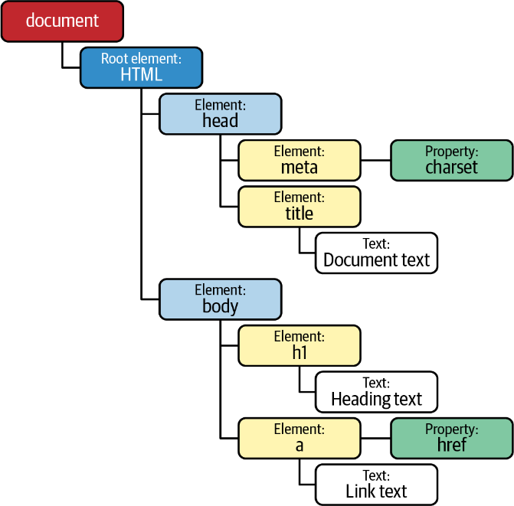
Figure 1. DOM structure generated from Example 5

WebElement Methods
Table 3-3 contains a summary of the available methods in the WebElement class. You will find examples of each method in the following parts of this section.
Method | Return | Description
click() | void | Perform a mouse click (i.e., a left-click) in the current element.
submit() | void | Send a web form (when the current element is a form).
sendKeys(CharSequence... keys) | void | Simulate typing with the keyboard (e.g., in input text elements).
clear() | void | Reset the value of an input text element.
getTagName() | String | Get the tag name of the element.
getDomProperty(String name) | String | Get the value of a DOM property.
getDomAttribute(String name) | String | Get the value of the element attribute as declared in its HTML markup.
getAttribute(String name) | String | Get the value of the given HTML attribute (e.g., class) as a String. More precisely, this method attempts to get a meaningful value of the DOM property with the given name if it exists. For instance, for boolean attributes (e.g., readonly), it returns true if it exists or null if not.
getAriaRole() | String | Get element role as defined on the W3C WAI-ARIA specification.
getAccessibleName() | String | Get element accessible name as defined by WAI-ARIA.
isSelected() | boolean | Determine if a checkbox, option in a select, or radio button is selected.
isEnabled() | boolean | Determine if an element is enabled or not (e.g., a form field).
isDisplayed() | boolean | Determine if an element is visible or not.
getText() | String | Get the visible text of the element, including its sub-elements (if any).
getLocation() | Point | Get the position (x and y coordinates) from the top-left corner of the rendered element.
getSize() | Dimension | Get the width and height of the rendered element.
getRect() | Rectangle | Get the location and size of the rendered element.
getCssValue(String propName) | String | Get the value of a CSS property of the element.
getShadowRoot() | SearchContext | Get the shadow root to search in a shadow tree (see “The Shadow DOM”).
findElements(By by) | List<WebElement> | Find all subelements that match the locator within the current element.
findElement(By by) | WebElement | Find the first subelement that matches the locator within the current element.

Location Strategies
Selenium WebDriver provides eight basic location strategies, summarized in Table 3-4. In addition, as explained in the next subsections, there are other advanced location strategies, namely, compound and relative locators.
We specify the basic locators using the class By in the Selenium WebDriver API. The following subsections show examples of all these strategies. We use the practice web form to that aim. Figure 3-2 shows a screenshot of this form.
Locator | Finds elements based on
Tag name | The name of HTML tag (e.g., a, p, div, img, etc.).
Link text | The exact text value displayed by a link (i.e., a HTML tag).
Partial link text | The text contained in a link (i.e., a HTML tag).
Name | The value of the attribute name.
Id | The value of the attribute id.
Class name | The value of the attribute class.
CSS selector | Patterns that follow the W3C Selectors recommendation. The original aim of CSS patterns is to select element(s) in a web page to apply CSS styles. Selenium WebDriver allows reusing these CSS selectors to find web elements and interact with them.
XPath | Queries that follow the XPath (XML Path Language) language. XPath is a W3C standard query language for selecting nodes from an XML-like document (e.g., web pages).
Table 4. Summary of the location strategies in Selenium WebDriver
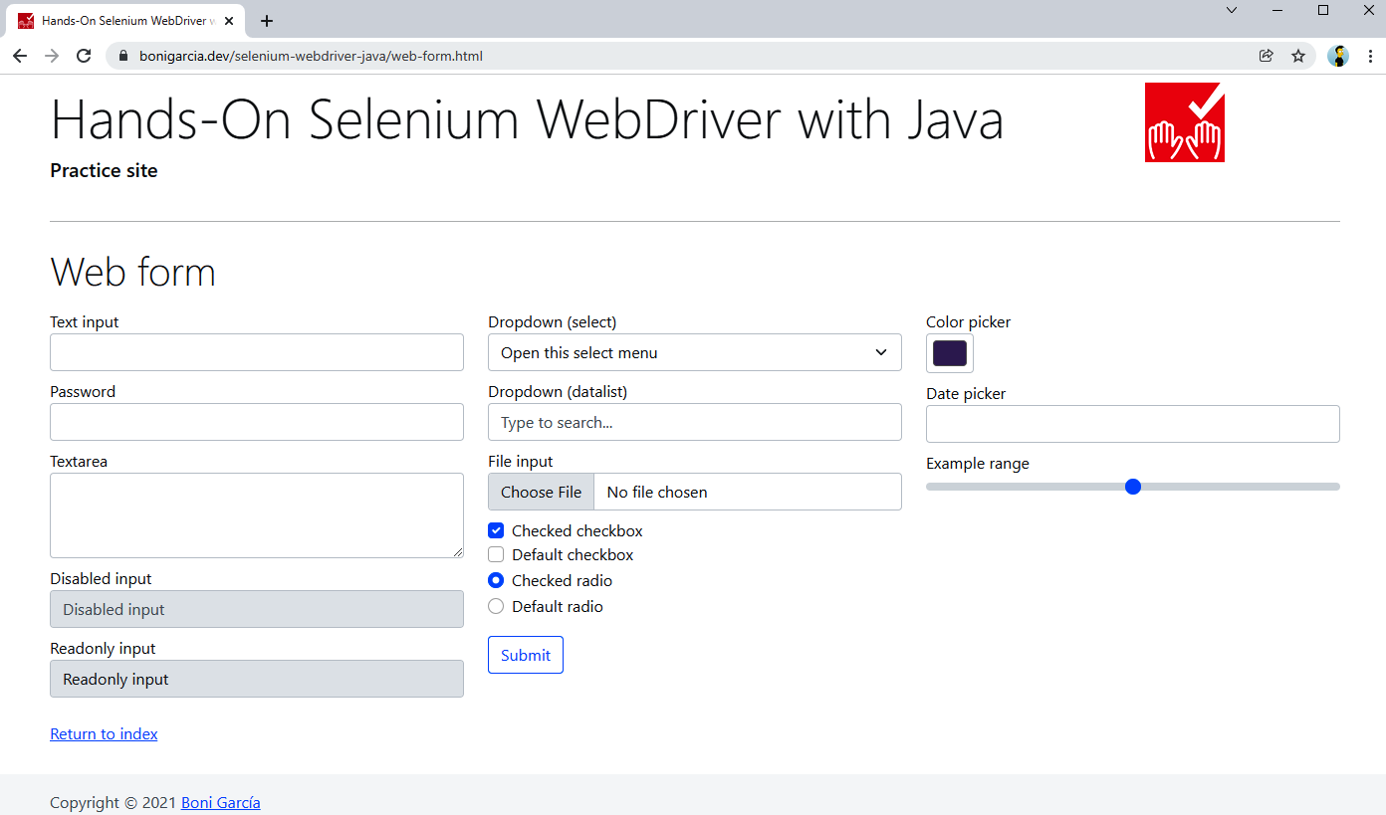
Figure 3-2. Practice web form used in the locator examples

Locating by HTML tag name
One of the most basic strategies for finding web elements is by tag name. Example 3-6 shows a test using this strategy. This test locates the text area available in the practice web form, whose HTML markup is the following:
<textarea class="form-control" id="my-textarea" rows="3"></textarea>
Example 3-6. Test using a locator strategy by tag name
@Test
void testByTagName() {
driver.get("https://bonigarcia.dev/selenium-webdriver-java/web-form.html");

WebElement textarea = driver.findElement(By.tagName("textarea"));
assertThat(textarea.getDomAttribute("rows")).isEqualTo("3");
}

We use the locator By.tagName("textarea") to find this element. In this case, since this is the only text area declared on the web page, we can be sure that the method findElement() will locate this element.
We ensure the attribute rows value is the same as defined in the HTML markup.

Locating by HTML attributes (name, id, class)
Another straightforward location strategy is to find web elements by an HTML attribute, i.e., name, id, or class. Consider the following input text available in the practice web form. Notice that it includes the standard attributes class, name, id, and the nonstandard attribute myprop (included to illustrate the difference between several WebDriver methods). Example 3-7 shows a test using this strategy.
<input type="text" class="form-control" name="my-text" id="my-text-id" myprop="myvalue">

Example 3-7. Test using locators by HTML attributes (name, id, and class)
@Test
void testByHtmlAttributes() {
driver.get("https://bonigarcia.dev/selenium-webdriver-java/web-form.html");

// By name
WebElement textByName = driver.findElement(By.name("my-text"));
assertThat(textByName.isEnabled()).isTrue();

// By id
WebElement textById = driver.findElement(By.id("my-text-id"));
assertThat(textById.getAttribute("type")).isEqualTo("text");
assertThat(textById.getDomAttribute("type")).isEqualTo("text");
assertThat(textById.getDomProperty("type")).isEqualTo("text");

assertThat(textById.getAttribute("myprop")).isEqualTo("myvalue");
assertThat(textById.getDomAttribute("myprop")).isEqualTo("myvalue");
assertThat(textById.getDomProperty("myprop")).isNull();

// By class name
List<WebElement> byClassName = driver.findElements(By.className("form-control"));
assertThat(byClassName.size()).isPositive();
assertThat(byClassName.get(0).getAttribute("name")).isEqualTo("my-text");
}

We locate the text input by name.
We assert that the element is enabled (i.e., the user can type in it).
We find the same text input element by id.
This assertion (and the next two) returns the same value since the attribute type is standard, and as previously explained, it becomes a property in the DOM.
This assertion (and the next two) return different values since the attribute myprop is not standard, and for this reason, it is not available as a DOM property.
We locate a list of elements by class.
We verify the list has more than one element.
We check that the first element found by class is the same as the input text located before.

Locating by link text
The last basic locator is by link text. This strategy is twofold: locate by exact and by partial text occurrence. We use a link in the practice web form to illustrate this locator in the following HTML markup. Then, Example 3-8 shows a test using these locators.
<a href="./index.html">Return to index</a>

Example 3-8. Test using locators by text link
@Test
void testByLinkText() {
driver.get("https://bonigarcia.dev/selenium-webdriver-java/web-form.html");

WebElement linkByText = driver.findElement(By.linkText("Return to index"));
assertThat(linkByText.getTagName()).isEqualTo("a");
assertThat(linkByText.getCssValue("cursor")).isEqualTo("pointer");

WebElement linkByPartialText = driver.findElement(By.partialLinkText("index"));
assertThat(linkByPartialText.getLocation()).isEqualTo(linkByText.getLocation());
assertThat(linkByPartialText.getRect()).isEqualTo(linkByText.getRect());
}

We locate an element by its full link text.
We check its tag name is a.
We check its CSS property cursor is pointer (i.e., the style typically used for clickable elements).
We find an element by partial link text. This link will be the same as in step 1.
We verify both elements share the same position and size.

Locating by CSS selectors
The strategies we have seen so far are easy to apply but also have some limitations. First, locating by tag name can be tricky since it is likely that the same tag will occur many times on a web page. Next, finding elements by HTML attributes (name, id, or class) is a limited approach since these attributes are not always available. In addition, ids can be autogenerated and volatile between different sessions. Lastly, the location by link text is limited only to links. To overcome these limitations, Selenium WebDriver provides two powerful location strategies: CSS selector and XPath.
There are many possibilities for creating CSS selectors. Table 3-5 shows a comprehensive summary with the basic CSS selectors.
Category | Syntax | Description | Example | Example explanation
Universal | * | Select all elements | * | Match all elements
Type | elementName | Select all elements with a given tag name | input | Match all <input> elements
Class | .classname | Select elements with a given class attribute | .form-control | Match all elements with class of form-control
Id | #id | Select elements with a given id attribute | #my-text-id | Match all elements with id my-text-id
Attribute | [attr] | Select elements with a given attribute | [target] | Match all elements with a target attribute
 | [attr=value] | Select elements with a given attribute and value | [target=_blank] | Match all elements with a target="_blank" attribute
 | [attr~=value] | Select elements with a given attribute containing some text value | [title~=hands] | Match all elements with a title attribute containing the word hands
 | [attr|=value] | Select elements with a given attribute equal to or starting by some value | [lang|=en] | Match all elements equal to or starting with en
 | [attr^=value] | Select elements with a given attribute starting by some value | a[href^="https"] | Match all links whose href attribute starts with https
 | [attr$=value] | Select elements with a given attribute ending by some value | a[href$=".pdf"] | Match all links whose href attribute ends with .pdf
 | [attr*=value] | Select elements with a given attribute value containing some string | a[href*="github"] | Match all links whose href attribute contains github
Table 3-5. Basic CSS selectors
The following HTML excerpt shows the hidden input text available in the practice web form. Then, Example 3-9 illustrates a possible way to locate this element using a CSS selector. One advantage of this locator is that the selector will still work even when changing the attribute name in HTML markup.
<input type="hidden" name="my-hidden">

Example 3-9. Test using a basic locator with CSS selector
@Test
void testByCssSelectorBasic() {
driver.get("https://bonigarcia.dev/selenium-webdriver-java/web-form.html");

WebElement hidden = driver.findElement(By.cssSelector("input[type=hidden]"));
assertThat(hidden.isDisplayed()).isFalse();
}

We use a CSS selector to locate the hidden input.
We check the hidden field is not visible.

There are plenty of possibilities to create advanced CSS selectors. Table 3-6 shows a summary with some of them. The complete reference of CSS selectors is available in the official W3C recommendation.
Category | Syntax | Description | Example | Example explanation
Grouping | , | Group two (or more) selectors | div, span | Match both <span> and <div> elements
Combinators | (space) | Select elements that are descendants | div span | Match all <span> that are inside a <div>
 | A > B | Select elements that are direct children of another element | ul > li | Match all <li> elements nested directly inside to <ul>
 | A ~ B | Select elements sharing the same parent (i.e., siblings), and the second element follows the first (not necessarily immediately) | p ~ span | Match all <span> that follow a <p> (immediately or not)
 | A + B | Sibling elements, and the second element immediately follows the first | h2 + p | Match all <p> that immediately follows <h2>
Pseudo | : | Select a CSS pseudoclass (i.e., a special state of the selected element) | a:visited | Match all already visited links
 | :nth-child(n) | Select elements based on their position in a group (starting from the beginning) | p:nth-child(2) | Match every second <p> child
 | :not(selector) | Select elements not matching a given selector | :not(p) | Match every element different from <p>
 | :nth-last-child(n) | Select elements based on their position in a group (starting from the end) | p:nth-last-child(2) | Match every second <p> child (counting from the last child)
 | :: | Select a CSS pseudoelement (i.e., a specific part of the selected element) | p::first-line | Match the first line of all <p> elements
Table 3-6. Advanced CSS selectors
Consider the following piece of HTML (as usual, contained in the practice web form). As you can see, there are a couple of checkboxes: one of them is checked, and the other is not. We can determine which element is checked using the Selenium WebDriver API and CSS selectors. To that aim, Example 3-10 uses CSS pseudoclass.
<input class="form-check-input" type="checkbox" name="my-check" id="my-check-1" checked>
<input class="form-check-input" type="checkbox" name="my-check" id="my-check-2">

Example 3-10. Test using advanced locators with CSS selectors
@Test
void testByCssSelectorAdvanced() {
driver.get("https://bonigarcia.dev/selenium-webdriver-java/web-form.html");

WebElement checkbox1 = driver.findElement(By.cssSelector("[type=checkbox]:checked"));
assertThat(checkbox1.getAttribute("id")).isEqualTo("my-checkbox-1");
assertThat(checkbox1.isSelected()).isTrue();

WebElement checkbox2 = driver.findElement(By.cssSelector("[type=checkbox]:not(:checked)"));
assertThat(checkbox2.getAttribute("id")).isEqualTo("my-checkbox-2");
assertThat(checkbox2.isSelected()).isFalse();
}
We use the pseudoclass checked to locate clicked checkboxes.
We check the element id is as expected.
We confirm the selected is checked.
We use the pseudoclass checked and the operator not to locate default checkboxes.
We check the element id is as expected.
We confirm the selected is unchecked.

Locating by XPath
XPath (XML Path Language) is a powerful way of navigating to the DOM of XML-like documents, such as HTML pages. It includes over two hundred built-in functions to create advanced queries to select nodes. There are two types of XPath queries. First, absolute queries use the symbol slash (/) to traverse the DOM from the root node. For example, considering the basic HTML page in Example 3-5, to select the link element present in this page using this approach, we need the following XPath query:
/html/body/a
Absolute XPath queries are easy to create, but they have a relevant inconvenience: any minimal change in the page layout would make a locator built with this strategy fail. For this reason, as a general rule, the usage of absolute XPaths is discouraged. Instead, relative queries are more convenient.
The general syntax for relative XPath queries is as follows:
//tagname[@attribute='value']
Example 3-11 shows a test with an XPath locator to select the hidden field in the practice web.

Example 3-11. Test using a basic locator with XPath
@Test
void testByXPathBasic() {
driver.get("https://bonigarcia.dev/selenium-webdriver-java/web-form.html");

WebElement hidden = driver.findElement(By.xpath("//input[@type='hidden']"));
assertThat(hidden.isDisplayed()).isFalse();
}
We locate the hidden field in the practice web.
We verify this element is not visible to the user.
The real power of XPath comes from its built-in functions. Table 3-7 contains some of the most relevant XPath functions. You can find the complete XPath reference in the W3C XPath Recommendations.
Category | Syntax | Description | Example | Example explanation
Attributes | contains(@attr, 'string') | Check if an attribute contains a string | //a[contains(@href, 'github')] | Match links with href containing github
 | starts-with(@attr, 'string') | Check if an attribute starts with a string | //a[starts-with(@href, 'https')] | Match all links using HTTPS
 | ends-with(@attr, 'string') | Check if an attribute end with a string | //a[ends-with(@href, https)] | Match all links to PDF documents
Text | text()='string' | Locate elements based on text content | //*[text()=click] | Match all elements with the text click
Child nodes | [index] | Locate children elements | //div/*[0] | First child of a <div>
Boolean | or | Logic operator or | //@type='submit' or @type='reset'] | Match buttons to submit and clear forms
 | and | Logic operator and | //@type='submit' and @id ='my-button'] | Match submit buttons with a given id
 | not() | Logic operator not | //@type='submit' and not(@id ='my-button')] | Match submit buttons different to a given id
Axes (used to locate relative nodes) | following::item | Nodes that come after the current one | //*[@type='text']//following::input | Match all input fields after the first text input
 | descendant::item | Select descendant elements (child, etc.) of current node | //*[@id='my-id']//descendant::a | Match all descendant links from a given parent node
 | ancestor::item | Select ancestor elements (parent, etc.) of current node | //input[@id='my-id']//ancestor::label | Match all antecedent labels from a given input text
 | child::item | Select children elements of current node | //*[@id='my-id']//child::li | Match all list element under a given node
 | preceding::item | Select all nodes that come before the current one | //*[@id='my-id']//preceding::input | Match all input before a given node
 | following-sibling::item | Select following nodes that come before the current one | //*[@id='my-id']//following-sibling::input | Match the next input before a given node
 | parent::item | Select parent of the current node | //*[@id='my-id']//parent::div | Match the parent div element of a given node
Table 3-7. Summary of relevant XPath built-in functions
Example 3-12 shows how to use XPath locators for the radio buttons available in the practice web form. The HTML markup for these radio buttons is:
<input class="form-check-input" type="radio" name="my-radio" id="my-radio-1" checked>
<input class="form-check-input" type="radio" name="my-radio" id="my-radio-2">

Example 3-12. Test using advanced locators with XPath
@Test
void testByXPathAdvanced() {
driver.get("https://bonigarcia.dev/selenium-webdriver-java/web-form.html");

WebElement radio1 = driver.findElement(By.xpath("//*[@type='radio' and @checked]"));
assertThat(radio1.getAttribute("id")).isEqualTo("my-radio-1");
assertThat(radio1.isSelected()).isTrue();

WebElement radio2 = driver.findElement(By.xpath("//*[@type='radio' and not(@checked)]"));
assertThat(radio2.getAttribute("id")).isEqualTo("my-radio-2");
assertThat(radio2.isSelected()).isFalse();
}

We use XPath to locate the checked radio buttons.
We check the element id is as expected.
We confirm the selected is checked.
We use XPath to locate the unchecked radio buttons.
We check the element id is as expected.
We confirm the selected is unchecked.

TIP
“What Strategy Should You Use?” provides a comparison between CSS selectors and XPath and gives some hints for selecting one or another locator strategies.

Finding Locators on a Web Page
As introduced in Table 1-4 in Chapter 1, there are different tools we can use to help generate locators for our WebDriver tests. This section shows how to use the main features of the built-in developer tools in major browsers, i.e., Chrome DevTools for Chromium-based browsers (e.g., Chrome and Edge) and Firefox Developer Tools (for Firefox).
You can open both of these developer tools by right-clicking on the portion of the web page UI that you want to test and then selecting the option menu Inspect. Figure 3-3 shows a screenshot of Chrome DevTools placed at the bottom of the browser (you can move it if you want).
Developer tools provide different ways to locate elements in a web page. First, we use the element selector by clicking on the icon (an arrow over a box) in the upper left corner of the developer tools pane. Then, we can move the mouse over the page to highlight each web element and inspect the elements panel to check their markup, attributes, etc.
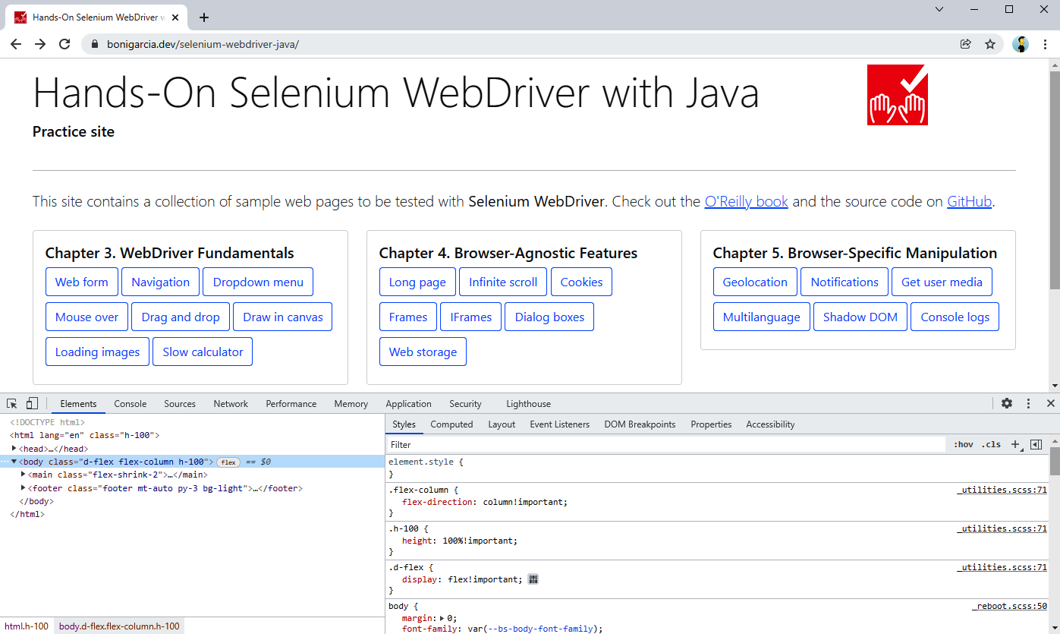
Figure 3-3. Use of Chrome DevTools while navigating the practice site
In the same view, we can use the tool to copy its CSS or XPath selector by right-clicking on the element and then selecting the menu option “Copy.” This mechanism allows getting the full CSS or XPath selector. It can be the first approach to generate a locator quickly, although I do not recommend using these locators directly since they tend to be brittle (i.e., linked to the current page layout) and are hard to read.
To create robust CSS or XPath locators, we need to think about the specific characteristics of the web pages we are working with and create a custom selector based on that knowledge. Again, the developer tools can help us in this task. We can press the key combination Ctrl + F to search by string, CSS selector, or XPath in Chrome DevTools. Figure 3-4 shows an example of this feature in action.
Notice we are using the practice web form, and we type the string #my-text-id, which corresponds to the element with a given id using a CSS selector. DevTools found the web element on the page and highlighted it.
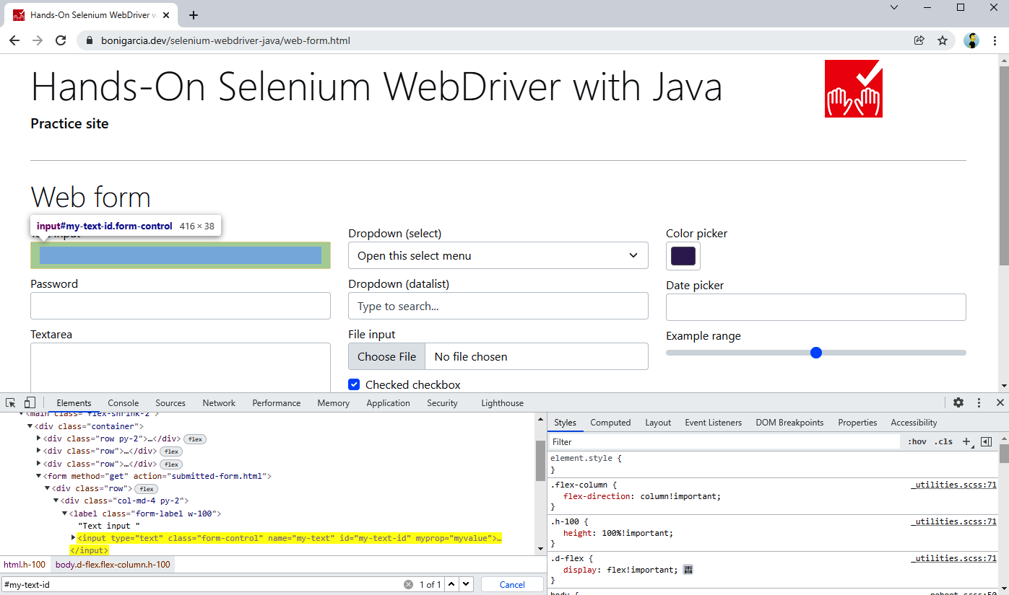
Figure 3-4. Searching CSS selector in Chrome DevTools
We can use a similar approach in Firefox. We need to use the console panel and type $$("css-selector") for searching by CSS selector or $x("xpath-query") for XPath queries. Figure 3-5 shows how to locate the first input text element of the practice web form by id, using a CSS selector and an XPath query.
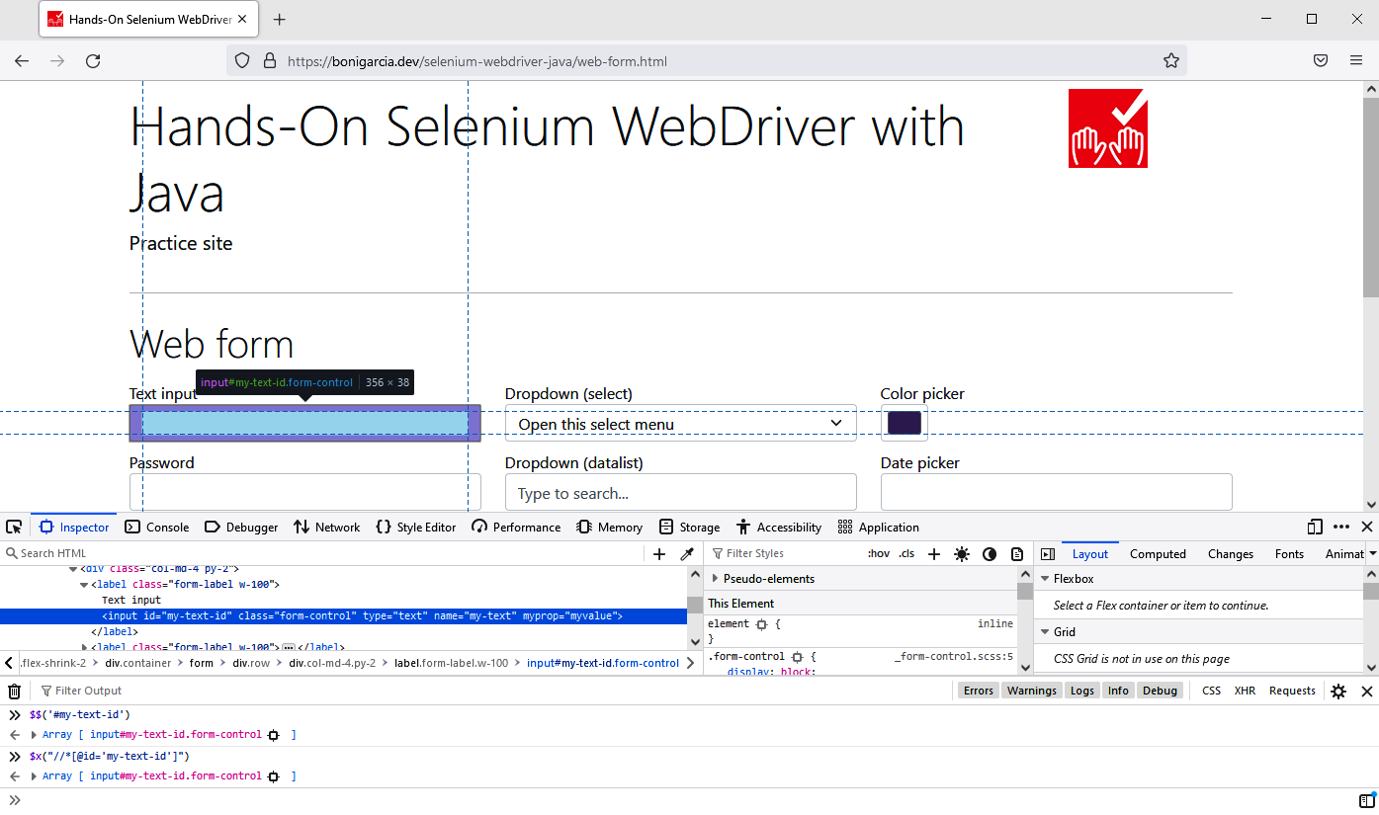
Figure 3-5. Searching CSS selector and XPath in Firefox Developer Tools

Compound Locators
The Selenium WebDriver API has several support classes that enable the composition of the different locator types we have seen. These classes are:
ByIdOrName(String idOrName)
It seeks by id, and if that is not available, it seeks by name.
ByChained(By... bys)
It seeks elements in a sequence (i.e., the second one should appear inside the first one, and so on).
ByAll(By... bys)
It seeks elements that match a number of location strategies (following an and logic condition for these locators).
Example 3-13 shows a test using ByIdOrName. This test looks for the following file-select field available in the practice web form. Notice that this field specifies the attribute name (but not id).
<input class="form-control" type="file" name="my-file">
Example 3-13. Test using by id or name compound locator
@Test
void testByIdOrName() {
driver.get("https://bonigarcia.dev/selenium-webdriver-java/web-form.html");

WebElement fileElement = driver.findElement(new ByIdOrName("my-file"));
assertThat(fileElement.getAttribute("id")).isBlank();
assertThat(fileElement.getAttribute("name")).isNotBlank();
}

We use a locator by id or name.
We check the element has the attribute name.
We verify the absence of the attribute name in the same element.

Example 3-14 shows two tests illustrating the difference between ByChained and ByAll. Both locators use the practice web form again. If you inspect its source code, you will notice that there are three single <div class="row"> inside the <form>.
Example 3-14. Test using by chained and by all compound locators
@Test
void testByChained() {
driver.get("https://bonigarcia.dev/selenium-webdriver-java/web-form.html");

List<WebElement> rowsInForm = driver.findElements(
new ByChained(By.tagName("form"), By.className("row")));
assertThat(rowsInForm.size()).isEqualTo(1);
}

@Test
void testByAll() {
driver.get("https://bonigarcia.dev/selenium-webdriver-java/web-form.html");

List<WebElement> rowsInForm = driver.findElements(
new ByAll(By.tagName("form"), By.className("row")));
assertThat(rowsInForm.size()).isEqualTo(5);
}

We use the locator using ByChained.
We find one element since only one row element is within the form.
We use the locator using ByAll.
We find five elements, since the locator matches a <form> element plus four <div class="row"> available on the page.

Relative Locators
Selenium WebDriver version 4 incorporates a new way to find elements in a web page: relative locators. These new locators aim to find web elements relative to another known element. This feature is based on the CSS box model. The model determines that each element of a web document is rendered using a rectangular box. Figure 3-6 shows an example of this box model for a given web element in the practice form.
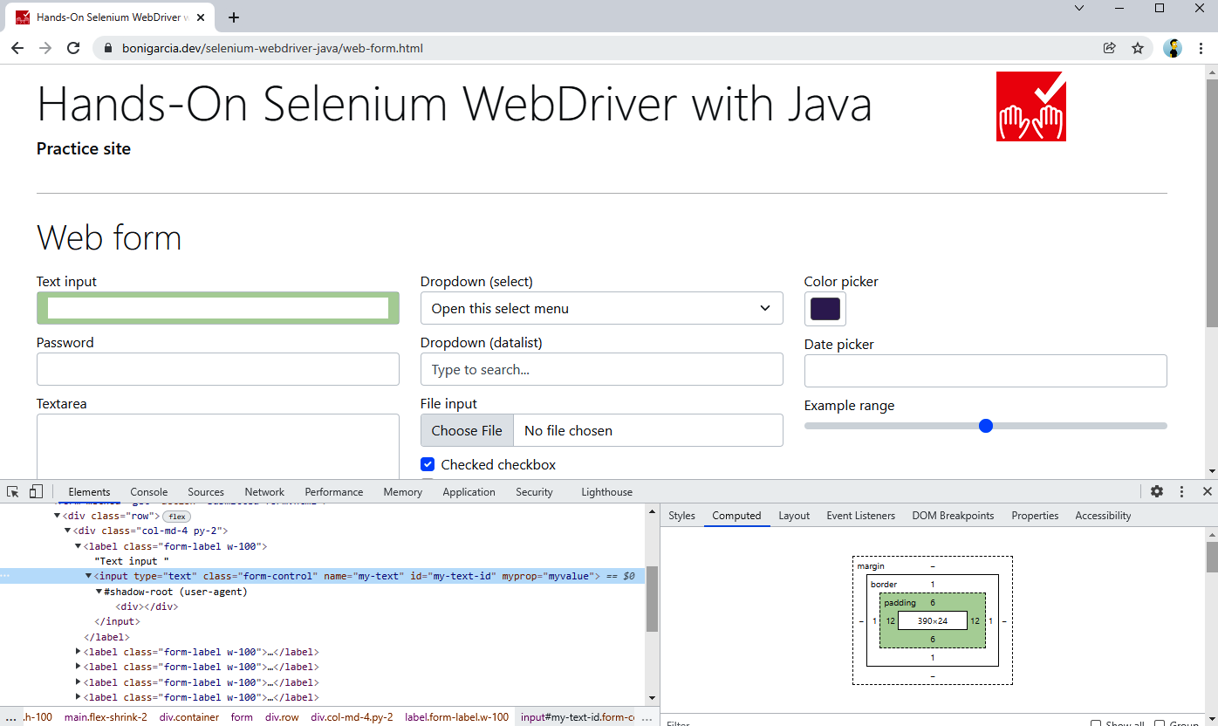
Figure 3-6. Practice form showing the box model of a web element
Using this box model, the relative locators available in the Selenium WebDriver API allow finding elements in relation to the position of another web element. To this aim, first, we need to locate that web element using the standard location strategies (e.g., by id, name, attribute, etc.). Then, we need to specify the locator type obtained by proximity to the original web element using the static method with of the class RelativeLocator. As a result, we get a RelativeBy object, which extends the abstract class By, used in the standard locator strategies. A RelativeBy object provides the following methods to carry out relative location:
above()
Finds element(s) located on the top of the original element.
below()
Finds element(s) located under the original element.
near()
Finds element(s) located close to the original element. The default distance to consider an element near to some other is one hundred pixels. This locator is overloaded to specify another distance.
toLeftOf()
Finds element(s) located at the left side of the original element.
toRightOf()
Finds element(s) located at the right side of the original element.
Example 3-15 shows a basic test using relative locators. Once again, we use the practice web form to illustrate this feature.
Example 3-15. Test using relative locators
@Test
void testRelativeLocators() {
driver.get("https://bonigarcia.dev/selenium-webdriver-java/web-form.html");

WebElement link = driver.findElement(By.linkText("Return to index"));
RelativeBy relativeBy = RelativeLocator.with(By.tagName("input"));
WebElement readOnly = driver.findElement(relativeBy.above(link));
assertThat(readOnly.getAttribute("name")).isEqualTo("my-readonly");
}

We locate the link whose text is Return to index.
We specify the relative locator type, which will be by tag name the input.
We use a relative locator to find a web element (which should be an input filed) above the original web element (i.e., a link).
We verify the element above the reference link is a read-only field (see Figure 3-2 to double-check it).
WARNING
Relative locators can be helpful for finding elements based on the relative position of other elements. On the other hand, this strategy can be very sensitive to page layout. For example, you need to be careful when using relative locators in responsive pages since the layout can vary depending on the viewport.

A challenging example
The examples we have seen so far are reasonably simple. Let’s now look at a more complex use case. A nondefault element in the practice web is the date picker. As its name suggests, this element provides a handy way to select dates using a web GUI. Since the CSS framework used in the practice site is Bootstrap, I implemented the date picker using bootstrap-datepicker. This date picker is attached to an input field. When the user clicks on this field, a calendar appears on the web page (see Figure 3-7). The user can select a given date by clicking the preferred date by navigating to the different days, months, and years.
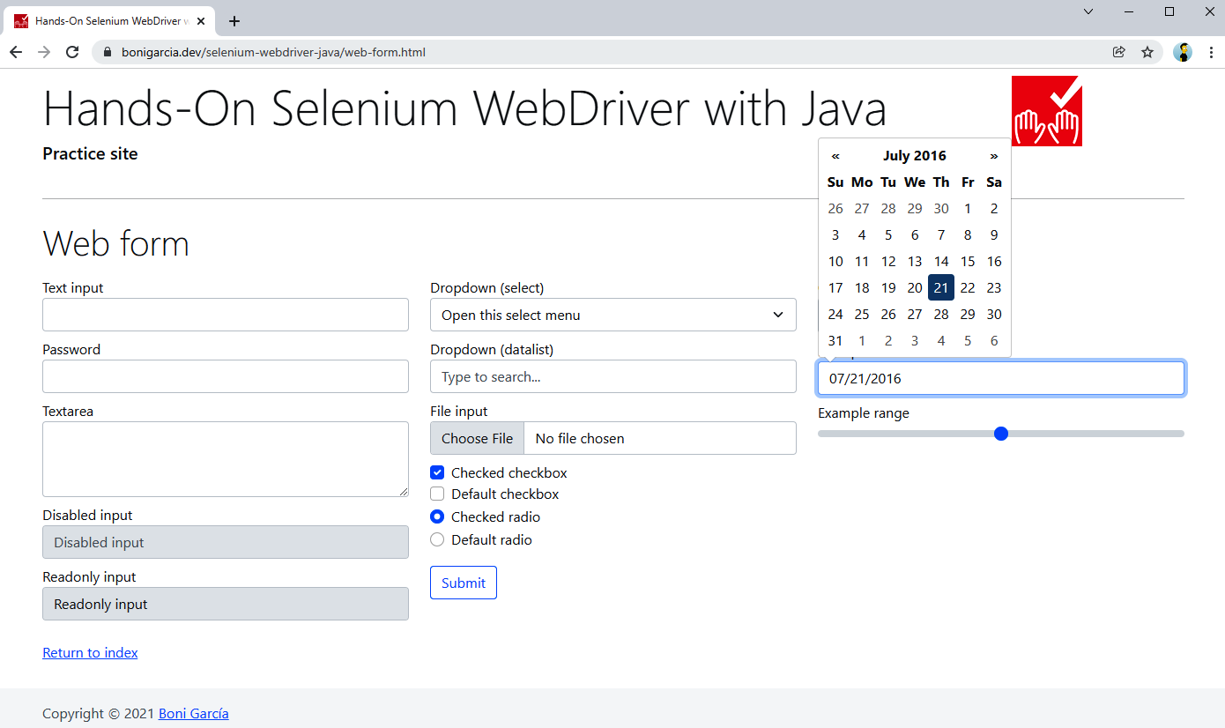
Figure 3-7. Date picker in the practice web form
We want to implement an automated test using Selenium WebDriver that selects the current day and month but the previous year by interacting with the date picker GUI. Example 3-16 shows the resulting implementation.
TIP
To follow this example, I recommend you open the practice web form (see URL in the code example) in your browser and use the developer tools to inspect the internal elements of the date picker selector, paying attention to the different selector strategies used.
Example 3-16. Test interacting with a date picker
@Test
void testDatePicker() {
driver.get("https://bonigarcia.dev/selenium-webdriver-java/web-form.html");

// Get the current date from the system clock
LocalDate today = LocalDate.now();
int currentYear = today.getYear();
int currentDay = today.getDayOfMonth();

// Click on the date picker to open the calendar
WebElement datePicker = driver.findElement(By.name("my-date"));
datePicker.click();

// Click on the current month by searching by text
WebElement monthElement = driver.findElement(By.xpath(
String.format("//th[contains(text(),'%d')]", currentYear)));
monthElement.click();

// Click on the left arrow using relative locators
WebElement arrowLeft = driver.findElement(
RelativeLocator.with(By.tagName("th")).toRightOf(monthElement));
arrowLeft.click();

// Click on the current month of that year
WebElement monthPastYear = driver.findElement(RelativeLocator
.with(By.cssSelector("span[class$=focused]")).below(arrowLeft));
monthPastYear.click();

// Click on the present day in that month
WebElement dayElement = driver.findElement(By.xpath(String.format(
"//td[@class='day' and contains(text(),'%d')]", currentDay)));
dayElement.click();

// Get the final date on the input text
String oneYearBack = datePicker.getAttribute("value");
log.debug("Final date in date picker: {}", oneYearBack);

// Assert that the expected date is equal to the one selected in the
// date picker
LocalDate previousYear = today.minusYears(1);
DateTimeFormatter dateFormat = DateTimeFormatter.ofPattern("MM/dd/yyyy");
String expectedDate = previousYear.format(dateFormat);
log.debug("Expected date: {}", expectedDate);

assertThat(oneYearBack).isEqualTo(expectedDate);
}
Get the current date from the system clock. We use the standard java.time API for this.
Click on the date picker to open the calendar. We use a locator by name (By.name("my-date")).
Click on the current month by searching by text. We use an XPath query for this locator. After this step, the rest of the months of the year appear in the date picker GUI.
Click on the left arrow using relative locators (i.e., right of the month element). After this step, the calendar moves to the previous year.
Click on the current month of that year. We use a CSS selector here.
Click on the present day in that month. We use an XPath query in this step. After the click, the date is selected, and the value appears in the input text.
Get the final date on the input text. We use a basic locator by attribute here.
Assert that the expected date is equal to the one selected in the date picker. We calculate the expected date using standard Java, and as usual, AssertJ for the assertion.

What Strategy Should You Use?
In this section, we review the different alternatives the Selenium WebDriver API allows for locating elements in a web page. This topic is one of the most fundamental routines for browser automation with Selenium WebDriver. Maybe you are asking yourself: What is the best strategy I should use? As Dr. Alfred Lanning (character in the novel and movie I, Robot) would say: “That, detective, is the right question.” In my opinion, that is a difficult question, and it has no simple answer. In other words, the answer to this question could be “it depends.” This section presents several hints for identifying a suitable locator strategy for common use cases. First, Table 3-8 compares the different locating strategies.
Locator | Pros | Cons | Typical use case
By attribute (id, name, class) | Easy to use | These attributes are not always available | Elements that define these attributes immutably (i.e., it does not change dynamically)
By link text (total or partial) | Easy to use | Only available for links | For text links
By tag name | Easy to use | Hard to select one specific element when the tag repeatedly appears on the page | When the tag is unique, or the resulting DOM node has a fixed position
By CSS selector or by XPath | Very powerful | It is not easy to write robust selectors | For complex locators
Compound locators | Easy way to compose existing locators | Limited to specific situations | When looking for id or name (ByIdOrName), when looking for nested elements (ByChained), and when using several strategies at the same time (ByAll)
Relative locators | Human language approach | It needs to be combined with other locators | Find element based on the relative position (above, below, near, etc.) of a known element
Table 8. Pros, cons, and typical use cases of the different locating strategies
As you can see in this table, CSS selectors and XPath share the same pros, cons, and use cases. Does it mean these strategies are the same? The answer is no. Both are very powerful and allow the creation of complex locators. Nevertheless, there are relevant distinctions between them. Table 3-9 summarizes these differences.
XPath | CSS selector
XPath allows bidirectional location, i.e., the traversal can be from parent to child and vice versa | CSS allows one-directional locations, i.e., the traversal is from parent to child only
XPath is slower in terms of performance | CSS has faster performance than XPath
XPath allows the identification of visible text on the screen using the text() function | CSS does not allow locating elements by its text content
Table 3-9. Some differences between XPath and CSS selector

To better illustrate the difference between XPath and CSS selectors, Table 3-10 compares specific locators using both strategies.
Locator | XPath | CSS selector
All elements | //* | *
All <div> elements | //div | div
Element by id | //*[@id='my-id'] | #my-id
Element by class | //*[contains(@class='my-class')] | .my-class
Element with attribute | //*[@attr] | *[attr]
Find by text in a <div> | //div[text()='search-string'] | Not possible
First child of a <div> | //div/*[1] | div>*:first-child
All <div> with a link child | //div[a] | Not possible
Next element in a <div> | //div/following-sibling::*[1] | div + *
Previous element of a <div> | //div/preceding-sibling::*[1] | Not possible
Table 3-10. Examples comparing XPath and CSS selector
In conclusion, we can see that XPath provides the most general strategy. Nevertheless, there are some cases in which the CSS selectors offer a friendlier syntax (e.g., locating by id or class) and better general performance.

Keyboard Actions
As introduced in Table 3-3, two main methods in WebDriver objects allow impersonating keyboard user actions: sendKeys() and clear(). Example 3-17 shows a test using these methods.

Example 3-17. Test impersonating keyboard events
@Test
void testSendKeys() {
driver.get("https://bonigarcia.dev/selenium-webdriver-java/web-form.html");

WebElement inputText = driver.findElement(By.name("my-text"));
String textValue = "Hello World!";
inputText.sendKeys(textValue);
assertThat(inputText.getAttribute("value")).isEqualTo(textValue);

inputText.clear();
assertThat(inputText.getAttribute("value")).isEmpty();
}

We use the practice web form to locate the input text named my-text.
We simulate a keyboard typing on it using the method sendKeys().
We assess the input value is as expected.
We reset its content using clear().
We assess the input value is empty.

MANUAL WAIT IN TEST TEARDOWN
If you inspect the complete code of some tests in the repository example, you will discover a pause in the teardown method using Thread.sleep(). As explained in “Waiting Strategies”, this type of wait is usually considered a bad smell (i.e., a characteristic in the source code that can lead to undesirable effects). Nevertheless, I have taken the liberty of using it in some examples for instructional purposes, i.e., to ease the manual inspection of the browser when executing the test locally. I recommend dropping these lines if you plan to reuse the examples in an actual test suite.

File Uploading
There are several use cases in which we will need to impersonate keyboard actions when interacting with web pages through Selenium WebDriver. The first one is file uploading. The standard mechanism to upload files for web applications is using <input> elements with type="file". For instance, the practice web form contains one of these elements:
<input class="form-control" type="file" name="my-file">
The Selenium WebDriver API does not provide a mechanism to handle file inputs. Instead, we should treat input elements for uploading files as regular text inputs, so we need to simulate the user typing them. In particular, we need to type the absolute file path to be uploaded. Example 3-18 illustrates how.

Example 3-18. Test uploading a file
@Test
void testUploadFile() throws IOException {
String initUrl = "https://bonigarcia.dev/selenium-webdriver-java/web-form.html";
driver.get(initUrl);

WebElement inputFile = driver.findElement(By.name("my-file"));
Path tempFile = Files.createTempFile("tempfiles", ".tmp");
String filename = tempFile.toAbsolutePath().toString();
log.debug("Using temporal file {} in file uploading", filename);
inputFile.sendKeys(filename);

driver.findElement(By.tagName("form")).submit();
assertThat(driver.getCurrentUrl()).isNotEqualTo(initUrl);
}

We locate the input field using a by-name strategy.
We create a temporal file using standard Java.
We type its absolute path to the input field.
We submit the form.
We verify that the resulting page (defined in action form attribute) is different from the initial web page.
TIP
The file path sent to the input file should correspond to an existing archive in the machine running the test. Otherwise, the test fails with an InvalidArgumentException exception. See “WebDriver Exceptions” in Chapter 5 for further details about exceptions.
When uploading a file to a remote browser (as explained in Chapter 6), we need to load the file from the local file system explicitly. The following line shows how to specify a local file detector.
((RemoteWebDriver) driver).setFileDetector(new LocalFileDetector());

Range Sliders
A similar situation happens with <input type="range"> form fields. These elements allow users to select a number in a range using a graphical slider. You can find an example in the practice web form:
<input type="range" class="form-range" name="my-range" min="0" max="10" step="1" value="5">
Again, the Selenium WebDriver API does not provide any particular utility to handle these fields. We can interact with them by impersonating keyboard actions with Selenium WebDriver. Example 3-19 shows a test interaction with these fields.

Example 3-19. Test selecting a number with a form slider
@Test
void testSlider() {
driver.get("https://bonigarcia.dev/selenium-webdriver-java/web-form.html");

WebElement slider = driver.findElement(By.name("my-range"));
String initValue = slider.getAttribute("value");
log.debug("The initial value of the slider is {}", initValue);

for (int i = 0; i < 5; i++) {
slider.sendKeys(Keys.ARROW_RIGHT);
}

String endValue = slider.getAttribute("value");
log.debug("The final value of the slider is {}", endValue);
assertThat(initValue).isNotEqualTo(endValue);
}
We send a keyboard key to the range field available in the practice web form. We use the class Keys available in the Selenium WebDriver API to handle special keyboard characters. In particular, we send the right arrow key to the slider, and as a result, it moves to the right (i.e., it increases the selected number within the range).
We assert the resulting selected value is different from the one in the original position.

Mouse Actions
In addition to the keyboard, the other primary input device for interacting with web applications is the computer mouse. First of all, the single-click (also known as left-click or simply click) is impersonated by the Selenium WebDriver API using the method click(), which is one of the methods available per WebElement in Selenium WebDriver. This section shows examples of two typical use cases using this feature: web navigation and interaction with checkboxes and radio buttons in web forms.
Other common mouse actions are right-clicking (also known as context-click), double-clicking, cursor movement, drag and drop, or mouseover. Selenium WebDriver allows impersonating these actions using a helper class called Actions. See the next section for further details. Finally, scrolling is possible in WebDriver by executing JavaScript. I explain this feature in “Executing JavaScript”.

Web Navigation
Example 3-20 shows a test implementing automated web navigation with Selenium WebDriver. This test locates links using XPath and clicks on them, invoking the method click(). In the end, it reads the text content of the web page body and verifies it contains an expected string.

Example 3-20. Test navigating by clicking on links
@Test
void testNavigation() {
driver.get("https://bonigarcia.dev/selenium-webdriver-java/");

driver.findElement(By.xpath("//a[text()='Navigation']")).click();
driver.findElement(By.xpath("//a[text()='Next']")).click();
driver.findElement(By.xpath("//a[text()='3']")).click();
driver.findElement(By.xpath("//a[text()='2']")).click();
driver.findElement(By.xpath("//a[text()='Previous']")).click();

String bodyText = driver.findElement(By.tagName("body")).getText();
assertThat(bodyText).contains("Lorem ipsum");
}

Checkboxes and Radio Buttons
Example 3-21 shows another basic use of the click() method for manipulating checkboxes and radio buttons. To verify the expected state of these elements after the click action, we use an assertion based on the result of the isSelected() method.
Example 3-21. Test interacting with checkboxes and radio buttons
@Test
void testNavigation() {
driver.get("https://bonigarcia.dev/selenium-webdriver-java/web-form.html");

WebElement checkbox2 = driver.findElement(By.id("my-checkbox-2"));
checkbox2.click();
assertThat(checkbox2.isSelected()).isTrue();

WebElement radio2 = driver.findElement(By.id("my-radio-2"));
radio2.click();
assertThat(radio2.isSelected()).isTrue();
}

User Gestures
Selenium WebDriver provides the class Actions, a powerful asset to automate different user actions, both for keyboard and mouse. This class follows the builder pattern. This way, you can chain several methods (i.e., different actions) and perform all of them at the end by calling build(). Table 3-11 summarizes the public methods available in this class. We review these methods through examples in the following subsections.
Method | Description
keyDown(CharSequence key)  keyDown(WebElement target, CharSequence key) | Send a single key (it could be a special character using the class Keys) in the current position (or a given element). The key remains pressed until calling to keyUp().
keyUp(CharSequence key)  keyUp(WebElement target, CharSequence key) | Release a key previously pressed with keyDown().
sendKeys(CharSequence... keys)  sendKeys(WebElement target, CharSequence... keys) | Send a key sequence in the current position (or a given element). This method is different from WebElement#sendKeys(CharSequence...) in two ways: 1) Modifier keys (e.g., Keys.CONTROL, Keys.SHIFT) are not released explicitly. 2) There is no refocus on the element, so Keys.TAB should work.
clickAndHold()  clickAndHold(WebElement target) | Click without releasing the current position (or the middle of a given element).
release()  release(WebElement target) | Release the left-click mouse button previously pressed with clickAndHold().
click()  click(WebElement target) | Click on the current position (or a given element).
doubleClick()  doubleClick(WebElement target) | Double-click on the current position (or element).
contextClick()  contextClick(WebElement target) | Right-click on the current position (or element).
moveToElement(WebElement target)  moveToElement(WebElement target,  int xOffset, int yOffset) | Move mouse cursor to the middle (or shifted to a given offset) of a given element.
moveByOffset(int xOffset,  int yOffset) | Move the mouse from its current position (0,0 by default) by the given offset.
dragAndDrop(WebElement source,  WebElement target)  dragAndDropBy(WebElement source,  int xOffset, int yOffset)  dragAndDropBy(WebElement source,  int xOffset, int yOffset) | This action consists of three steps: 1) Click and hold at the middle (or shifted by a given offset) of the source element location. 2) Move the mouse to the target element location. 3) Release the mouse click.
pause(long pause)  pause(Duration duration) | Perform a pause in the actions chain (in milliseconds or using a Java Duration).
build() | Generate a composite action containing all previous actions.
perform() | Execute the composite action.
Table 3-11. Actions methods

Right-Click and Double-Click
You can find a demo page using three dropdown menus on the practice site (see Figure 3-8). On this page, the first dropdown menu appears when clicking on its button, the second one uses the right-click, and the third one requires a double-click. Example 3-22 shows a test using this page to impersonate user gestures through the WebDriver class Actions.
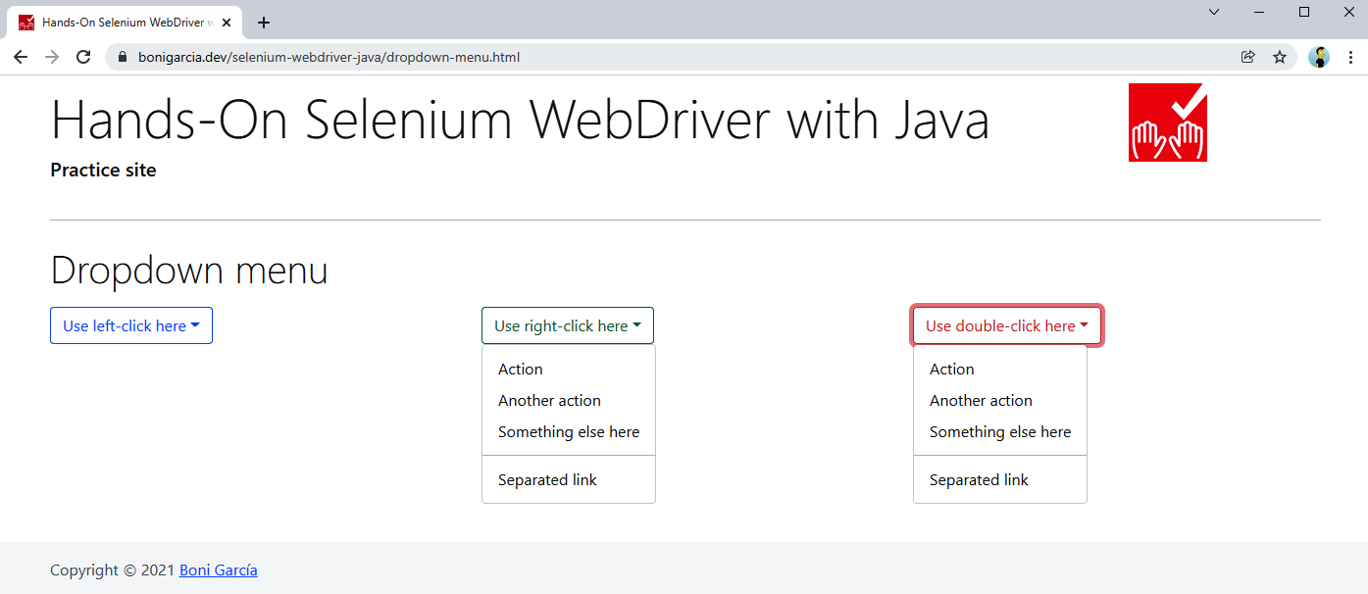
Figure 3-8. Practice web page with dropdown menus

Example 3-22. Test using context and double-click
@Test
void testContextAndDoubleClick() {
driver.get("https://bonigarcia.dev/selenium-webdriver-java/dropdown-menu.html");
Actions actions = new Actions(driver);

WebElement dropdown2 = driver.findElement(By.id("my-dropdown-2"));
actions.contextClick(dropdown2).build().perform();
WebElement contextMenu2 = driver.findElement(By.id("context-menu-2"));
assertThat(contextMenu2.isDisplayed()).isTrue();

WebElement dropdown3 = driver.findElement(By.id("my-dropdown-3"));
actions.doubleClick(dropdown3).build().perform();
WebElement contextMenu3 = driver.findElement(By.id("context-menu-3"));
assertThat(contextMenu3.isDisplayed()).isTrue();
}

We use contextClick() in the middle dropdown menu.
We verify the middle menu is correctly displayed.
We use doubleClick() in the right dropdown menu.
We verify the right menu is correctly displayed.

Mouseover
The second example handling Actions uses a sample web page implementing a mouseover. This page displays four images. Each one shows a text label below the image when the mouse pointer is over. Example 3-23 contains a test that uses this page. Figure 3-9 shows this page when the mouse is over the first picture.

Example 3-23. Test using mouseover
@Test
void testMouseOver() {
driver.get("https://bonigarcia.dev/selenium-webdriver-java/mouse-over.html");
Actions actions = new Actions(driver);

List<String> imageList = Arrays.asList("compass", "calendar", "award","landscape");
for (String imageName : imageList) {
String xpath = String.format("//img[@src='img/%s.png']", imageName);
WebElement image = driver.findElement(By.xpath(xpath));
actions.moveToElement(image).build().perform();

WebElement caption = driver.findElement(
RelativeLocator.with(By.tagName("div")).near(image));

assertThat(caption.getText()).containsIgnoringCase(imageName);
}
}
We iterate a string list to locate the four images of the page.
We use XPath to find each <img> web element.
We use moveToElement() to move the mouse pointer to the middle of each image.
We use relative locators to find the displayed label.
We use assertions to verify that the text is as expected.

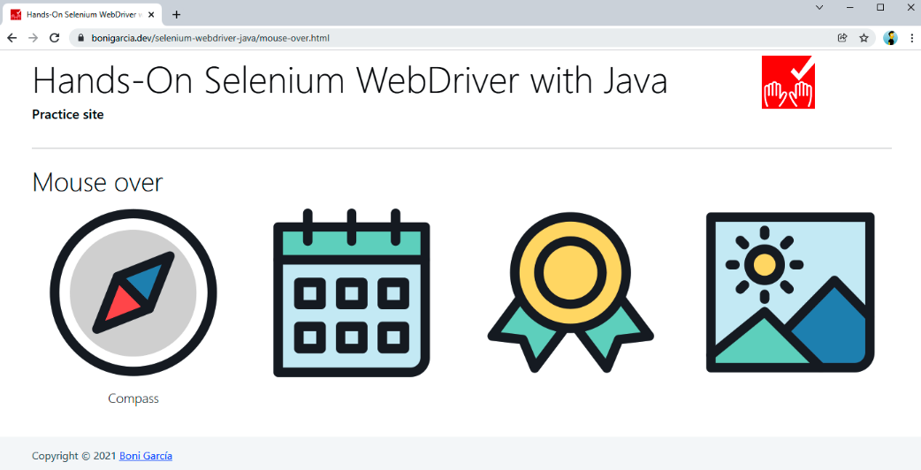
Figure 3-9. Practice web page with mouse-over images

Drag and Drop
Example 3-24 illustrates the use of drag and drop. This test uses the practice web shown in Figure 3-10.

Example 3-24. Test using drag and drop
@Test
void testDragAndDrop() {
driver.get("https://bonigarcia.dev/selenium-webdriver-java/drag-and-drop.html");
Actions actions = new Actions(driver);

WebElement draggable = driver.findElement(By.id("draggable"));
int offset = 100;
Point initLocation = draggable.getLocation();
actions.dragAndDropBy(draggable, offset, 0)
.dragAndDropBy(draggable, 0, offset)
.dragAndDropBy(draggable, -offset, 0)
.dragAndDropBy(draggable, 0, -offset).build().perform();
assertThat(initLocation).isEqualTo(draggable.getLocation());

WebElement target = driver.findElement(By.id("target"));
actions.dragAndDrop(draggable, target).build().perform();
assertThat(target.getLocation()).isEqualTo(draggable.getLocation());
}

We locate the draggable element.
We use dragAndDropBy() to move this element a fixed number of pixels (100) four times (right, bottom, left, and up).
We assert the element position is the same as the beginning.
We find a second element (not draggable this time).
We use dragAndDrop() to move the draggable element to the second one.
We assert the position of both elements is the same.

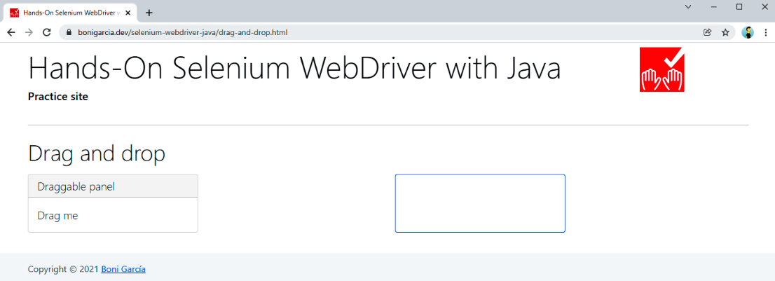
Figure 3-10. Practice web page with a draggable element

Click and Hold
The following example shows complex user gestures, including click and hold. To that aim, we practice with the web page in Figure 3-11.
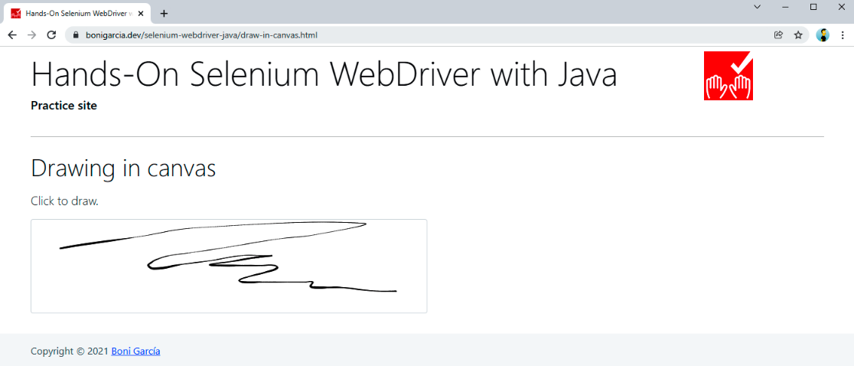
Figure 3-11. Practice web page with a drawable canvas
This page uses an open source JavaScript library called Signature Pad to draw signatures in HTML canvas using the mouse. Example 3-25 shows a test using it.

Example 3-25. Test drawing a circumference on a canvas
@Test
void testClickAndHold() {
driver.get("https://bonigarcia.dev/selenium-webdriver-java/draw-in-canvas.html");
Actions actions = new Actions(driver);

WebElement canvas = driver.findElement(By.tagName("canvas"));
actions.moveToElement(canvas).clickAndHold();

int numPoints = 10;
int radius = 30;
for (int i = 0; i <= numPoints; i++) {
double angle = Math.toRadians(360 * i / numPoints);
double x = Math.sin(angle) * radius;
double y = Math.cos(angle) * radius;
actions.moveByOffset((int) x, (int) y);
}
actions.release(canvas).build().perform();
}

We locate the canvas by tag name.
We move the mouse to this element with moveToElement() and then add the action clickAndHold() (for drawing into the canvas) to the actions pipeline.
We iterate using a fixed number of points, using the equation to find the points in a circumference.
We use the circumference points (x and y) to move the mouse by offset (moveByOffset()). Since the click is held from the previous step, the resulting compound action will move the mouse while the click button is pressed.
We release the click, build the action, and carry out the whole chain. As a result, a circumference should appear on the canvas.

Copy and Paste
This last example for user gestures automates a pervasive user action: copy and paste using the keyboard. Here, we use the web form available on the practice website. Example 3-26 shows a test impersonating copy and paste.

Example 3-26. Test impersonating copy and paste
@Test
void testCopyAndPaste() {
driver.get("https://bonigarcia.dev/selenium-webdriver-java/web-form.html");
Actions actions = new Actions(driver);

WebElement inputText = driver.findElement(By.name("my-text"));
WebElement textarea = driver.findElement(By.name("my-textarea"));

Keys modifier = SystemUtils.IS_OS_MAC ? Keys.COMMAND : Keys.CONTROL;
actions.sendKeys(inputText, "hello world").keyDown(modifier)
.sendKeys(inputText, "a").sendKeys(inputText, "c")
.sendKeys(textarea, "v").build().perform();

assertThat(inputText.getAttribute("value")).isEqualTo(textarea.getAttribute("value"));
}

We locate two web elements: an input text and a text area.
We use a modifier key for sending the combination Ctrl + C for copying (in Windows and Linux) or Cmd + C for copying (in macOS). To this aim, we use the class SystemUtils, available in the open source library Apache Commons IO (this dependency is used transitively in the Maven/Gradle project).
We implement the actions chain composed of the following steps:
- Send the char sequence hello world to the input text.
- Press the key modifier (Ctrl or Cmd, depending on the operating system). Remember that this key remains pressed until we explicitly release it.
- We send the key a to the input text. Since the modifier is active, the resulting combination is Ctrl + A (or Cmd + A), and as a result, all the text present in the input text is selected.
- We send the key c to the input text. Again, since the modifier is active, the combination is Ctrl + C (or Cmd + C), and the input text is copied to the clipboard.
- We send the key v to the text area. This means sending Ctrl + V (or Cmd + V), and the clipboard content is pasted to the text area.
We assert the content of both elements (input text and text area) is the same at the end of the text.

Waiting Strategies
Web applications are client-server distributed services in which the clients are the web browsers and the web servers are usually remote hosts. The intermediate network latency could affect the reliability of a WebDriver test. For instance, in the case of high-latency networks or overloaded servers, a slow response might negatively affect the expected conditions of WebDriver tests. In addition, modern web applications tend to be dynamic and asynchronous. Nowadays, JavaScript allows executing nonblocking (i.e., asynchronous) operations using different mechanisms, such as callbacks, promises, or async/await. In addition, we can retrieve data from other servers asynchronously, for example, using AJAX (Asynchronous JavaScript and XML) or REST (REpresentational State Transfer) services.
All in all, it is of paramount importance to have mechanisms pause and wait for certain conditions in our WebDriver tests. For this reason, the Selenium WebDriver API provides different waiting assets. The three principal waiting strategies are implicit, explicit, and fluent waits. The following subsections explain and show examples.
WARNING
For waiting in Java, you might think about including Thread.sleep() commands in your code. On the one hand, it is a simple solution, but on the other hand, it is considered a bad smell (i.e., a weak sign) that could lead to unreliable tests (since the delay conditions can change). As a general rule, I strongly discourage you from using it. Instead, consider using the aforementioned wait strategies.

Implicit Wait
The first waiting strategy provided by Selenium WebDriver is called implicit. This mechanism allows specifying an amount of time before throwing an exception when finding an element. By default, this wait has a value of zero seconds (i.e., it does not wait at all). But when we define an implicit wait value, Selenium WebDriver polls the DOM during the implicit wait value when trying to find an element. The poll time is specific to the driver implementation and is frequently less than five hundred ms. If the element is present in the elapsed time, the script continues. Otherwise, it throws an exception.
Example 3-27 illustrates this strategy. This test uses a practice page (see Figure 3-12) that dynamically loads several images into the DOM. Since these images are not available just before the page is loaded, we need to wait for these images to be available.
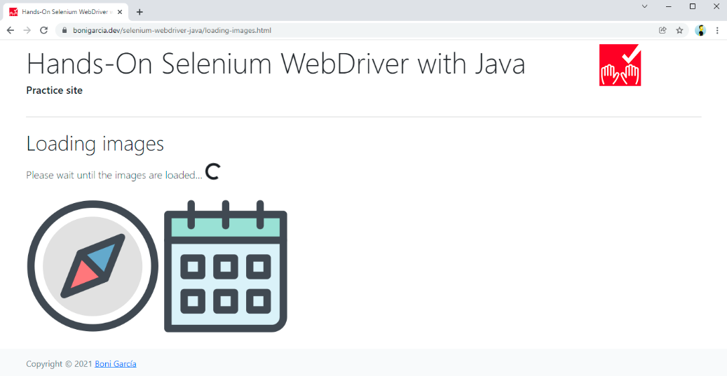
Figure 3-12. Practice web page loading images

Example 3-27. Test using an implicit wait in the “loading images” page
@Test
void testImplicitWait() {
driver.get("https://bonigarcia.dev/selenium-webdriver-java/loading-images.html");
driver.manage().timeouts().implicitlyWait(Duration.ofSeconds(10));

WebElement landscape = driver.findElement(By.id("landscape"));
assertThat(landscape.getAttribute("src")).containsIgnoringCase("landscape");
}

Before interacting with the elements, we specify an implicit wait strategy. In this case, we set up a timeout of 10 seconds.
In the following calls, we use the Selenium WebDriver API as usual.
TIP
You can play with this feature by dropping the implicit wait from the test (step 1). If you do that, you will notice that the test fails in step 2 due to a NoSuchElementException.
Although supported by the Selenium WebDriver API, implicit waits have different inconveniences you need to know. First, an implicit wait only works on finding elements. Second, we cannot customize its behavior since its implementation is driver-specific. Finally, and since implicit waits are applied globally, checking for the absence of web elements usually increases the execution time for the entire script. For these reasons, implicit waits are typically considered bad practice in most cases, and explicit and fluent waits are preferred instead.

Explicit Wait
The second waiting strategy, called explicit, allows pausing the test execution a maximum amount of time until a specific condition happens. To use this strategy, we need to create an instance of WebDriverWait, using the WebDriver object as the first constructor argument, and an instance of Duration as the second argument (to specify the timeout).
Selenium WebDriver provides a comprehensive set of expected conditions using the ExpectedConditions class. These conditions are very readable, and it does not require further explanation to understand their purpose. I recommend you use an autocomplete feature in your favorite IDE to discover all the possibilities. For example, Figure 3-13 shows this list in Eclipse.
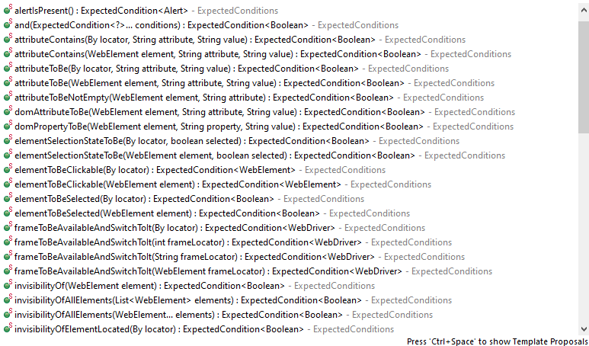
Figure 3-13. Autocomplete in Eclipse for the ExpectedConditions class
Example 3-28 shows a test using an explicit wait. In the example, we use the presenceofElementLocated condition to wait until one of the images is available on the practice web page.

Example 3-28. Test using an explicit wait in the “loading images” page
@Test
void testExplicitWait() {
driver.get("https://bonigarcia.dev/selenium-webdriver-java/loading-images.html");
WebDriverWait wait = new WebDriverWait(driver, Duration.ofSeconds(10));

WebElement landscape = wait.until(ExpectedConditions
.presenceOfElementLocated(By.id("landscape")));
assertThat(landscape.getAttribute("src")).containsIgnoringCase("landscape");
}
We create the wait instance. In this case, the selected timeout is 10 seconds.
We explicitly wait for a given condition (in this case, the presence of a given element) by invoking the until() method in the WebDriverWait object. To achieve a more readable statement, you can also statically import this expected condition (presenceOfElementLocated). In this book, I decided to keep the class name (ExpectedConditions) in these conditions to ease the autocomplete feature in IDEs as described before.
Example 3-29 shows another test using explicit waits. This test uses another practice web page called “slow calculator,” which contains a GUI of a basic calculator, tuned to wait a configurable time to get the result of basic arithmetic operations (by default, five seconds). Figure 3-14 shows a screenshot of this page.

Example 3-29. Test using an explicit wait in the “slow calculator” page
@Test
void testSlowCalculator() {
driver.get("https://bonigarcia.dev/selenium-webdriver-java/slow-calculator.html");

// 1 + 3
driver.findElement(By.xpath("//span[text()='1']")).click();
driver.findElement(By.xpath("//span[text()='+']")).click();
driver.findElement(By.xpath("//span[text()='3']")).click();
driver.findElement(By.xpath("//span[text()='=']")).click();

// ... should be 4, wait for it
WebDriverWait wait = new WebDriverWait(driver, Duration.ofSeconds(10));
wait.until(ExpectedConditions.textToBe(By.className("screen"), "4"));
}
We use XPath locators to click the buttons corresponding to operation 1 + 3.
Since the test should wait until the result is ready, we explicitly wait for that. In this case, the condition is the text of the element with a class name screen is equal to 4.
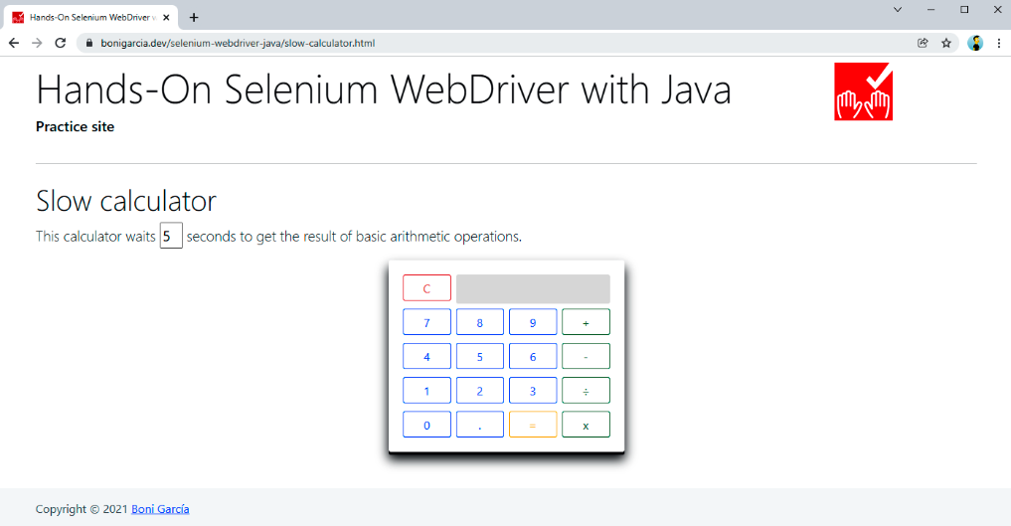
Figure 3-14. Practice web page with the “slow calculator” demo

Fluent Wait
The last strategy is a fluent wait. This mechanism is a generalization of explicit waits. In other words, we use fluent waits for pausing the test until certain conditions, but in addition, fluent waits provide fine-grained configuration capabilities. Table 3-12 summarizes the methods available in FluentWait. As its name suggests, this class provides a fluent API, and therefore, we can chain several invocations in the same line. Example 3-30 shows a test using fluent wait.
Method | Description
withTimeout(Duration timeout) | Timeout using Java Duration
pollingEvery(Duration interval) | How often the condition is evaluated (five hundred ms by default)
withMessage(String message)  withMessage(Supplier<String> messageSupplier) | Custom error message
ignoring(Class<? extends Throwable> exceptionType)  ignoring(Class<? extends Throwable> firstType,  Class<? extends Throwable> secondType)  ignoreAll(Collection<Class<? extends Throwable>> types) | Ignore specific exceptions while waiting for a condition
until(Function<? super T, V> isTrue) | Expected condition
Table 3-12. Fluent wait methods

Example 3-30. Test using a fluent wait
@Test
void testFluentWait() {
driver.get("https://bonigarcia.dev/selenium-webdriver-java/loading-images.html");
Wait<WebDriver> wait = new FluentWait<>(driver)
.withTimeout(Duration.ofSeconds(10))
.pollingEvery(Duration.ofSeconds(1))
.ignoring(NoSuchElementException.class);

WebElement landscape = wait.until(ExpectedConditions .presenceOfElementLocated(By.id("landscape")));
assertThat(landscape.getAttribute("src")).containsIgnoringCase("landscape");
}
As you can see, this test is very similar to Example 3-28, although using a FluentWait instance, we can specify additional characteristics. In this case, we change the poll time to one second.
TIP
The class WebDriverWait (presented in the previous subsection) extends the generic class FluentWait. Thus, you can use all the methods shown in Table 3-12 for explicit waits too.

RELATED FEATURES IN SELENIUM WEBDRIVER
In addition to the previously introduced waiting strategies, there are other complementary characteristics in Selenium WebDriver you should be aware of:
Loading strategies
Selenium WebDriver allows specifying different approaches for page loading. This feature is accessible through browser-specific capabilities (e.g., using ChromeOptions, FirefoxOptions, etc.). For this reason, I explain this feature in “Page Loading Strategies”.
Timeouts
Selenium WebDriver allows specifying the maximum elapsed time for page and script loading. I explain this feature in “Timeouts”.

Summary and Outlook
This chapter presented the foundations of the Selenium WebDriver API. First, you learned how to create and shut down WebDriver instances. These objects represent a browser controlled with Selenium WebDriver. This way, we use an instance of ChromeDriver for Chrome, FirefoxDriver for Firefox, etc. Second, you looked at Web​Ele⁠ment, a class representing different web page elements (e.g., links, images, form fields, etc.). Selenium WebDriver provides several strategies to locate web elements: by HTML attribute (id, name, or class), tag name, link text (complete or partial), CSS selector, and XPath. We also looked at a brand-new strategy of Selenium WebDriver 4 called relative locators. Then, we covered user actions’ impersonation, using the keyboard and the mouse. You can use these actions from simple actions (e.g., clicking a link, filling a text input, etc.) to complex user gestures (e.g., drag and drop, click and hover, etc.). Finally, we examined the ability to wait in Selenium WebDriver tests. This feature is critical due to the current distributed, dynamic, and asynchronous nature of web applications. There are three main wait strategies in Selenium WebDriver: implicit (specify a general timeout to wait for elements), explicit (pause test execution until a given condition), and fluent (extension of an explicit wait with some fine-grained setup).
The next chapter continues digging into the Selenium WebDriver API. In particular, Chapter 4 reviews those interoperable features in different browsers (Chrome, Edge, Firefox, etc.). Among these features, you will discover how to execute JavaScript, specify event listeners, configure timeouts for page and script loading, manage the browser history, make screenshots, manipulate cookies, manipulate dropdown lists (i.e., selects and data lists), handle window targets (i.e., tabs, frames, and iframes) and dialog boxes (i.e., alerts, prompts, confirmation, and modal pop-ups), use web storage, and understand the WebDriver exceptions.

